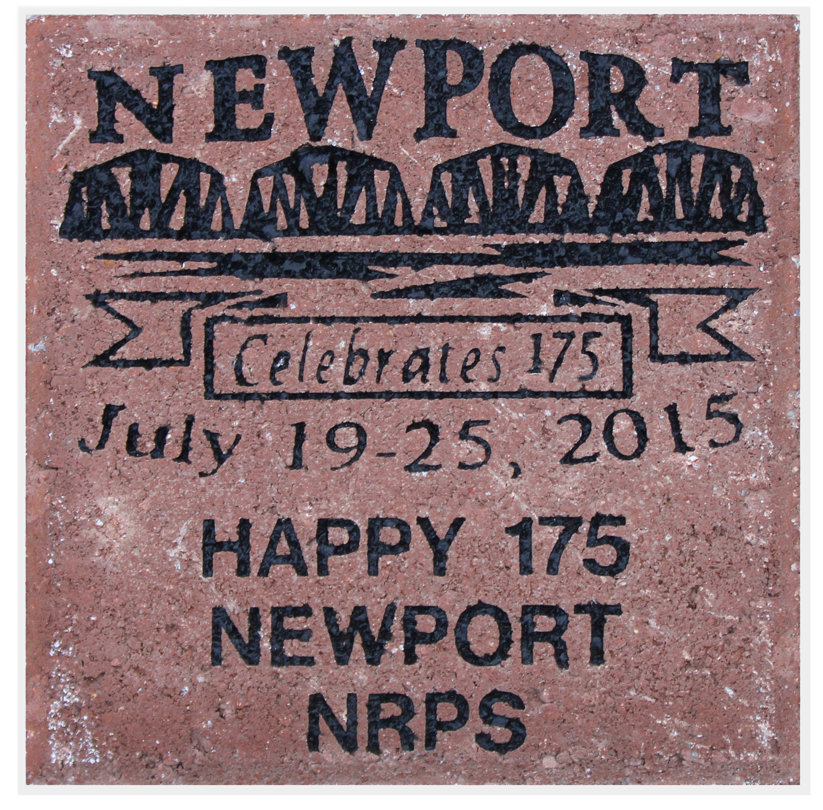
New
Design
Buy a Limited Edition Brick

Newport will celebrate its 175th anniversary from July 19 to 25, 2015. The Newport Revitalization and Preservation Society (NRPS) is selling limited edition bricks as a fundraiser for the event. They will be placed on the brick edge to the sidewalks along Market Street.

The 8” by 8” engraved brick will bear a personalized message of your choice below the Newport Celebrates 175 logo. There may be up to 3 lines per brick, 13 characters per line including spaces and punctuation.

Bricks are $65.00 each. Proceeds will be used for NRPS projects in Newport. The purchase is tax deductible.

Thank you for your generosity and support for the community.

Name ____________________________________________________________
Address___________________________________________________________
City ______________________________ State _____________ Zip __________
Phone ________________________ Email ______________________________

Limit: 39 Characters, 3 lines of 13 characters each including spaces and punctuation. Please print clearly.

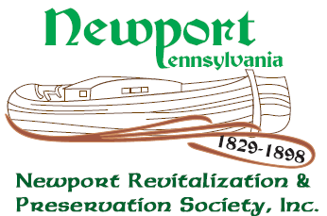
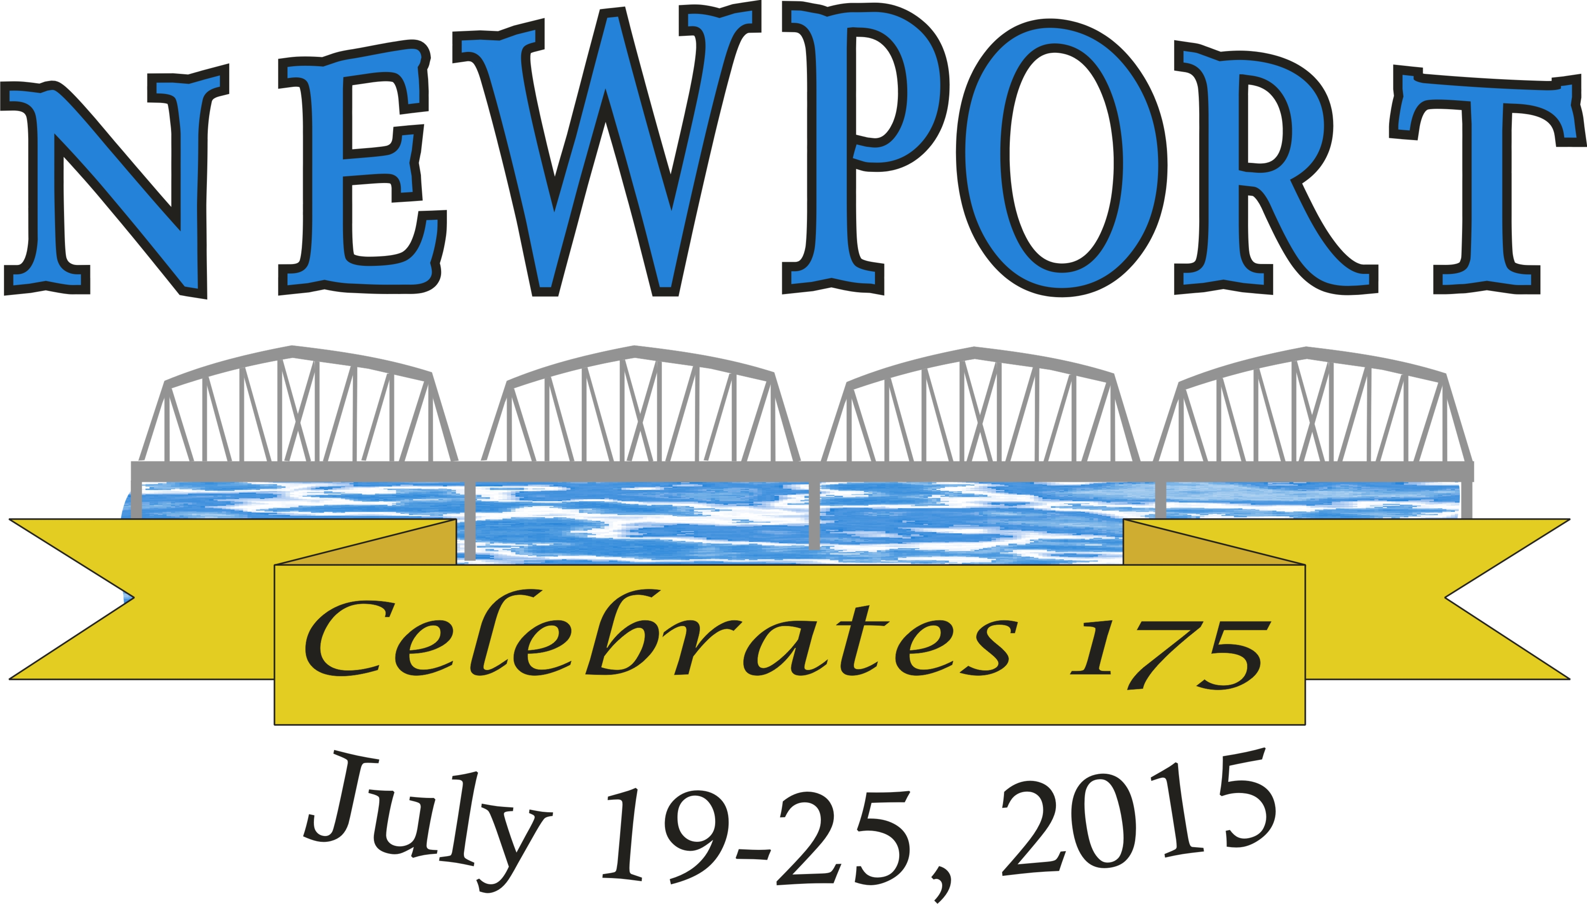
Return this form and check (payable to NRPS) or cash to
NRPS, PO Box 13, Newport, PA 17074.

