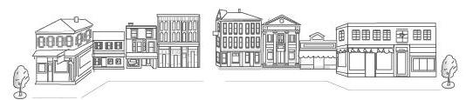

Be a Part of History
Buy a Brick
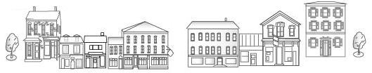

Thanks to Newport Borough’s Streetscape Enhancement Project, the downtown area is charming. You can purchase a personalized brick that will be used to pave around the outside of the sidewalk around the square. The brick will bear a personalized message of your choice. This gift will live on in the community as we continue to support this project.

Bricks are available for $50.00 each. The engraved bricks measure 4” x 8”. There may be up to 3 lines per brick, 13 characters per line including spaces and punctuation. All profits will benefit the Newport Revitalization and Preservation Society. Bricks will be placed along Market Street. The purchase is tax deductible.

Thank you for your generosity and support for the community. We look forward to seeing you in downtown Newport.

Sincerely,

Frank Campbell
President
Newport Revitalization and Preservation Society

Name __________________________________________________
Address_________________________________________________
City ______________________State ______________ Zip _________
Phone _____________________

Limit: 39 Characters, 3 lines of 13 characters each including spaces and punctuation. Please print clearly.

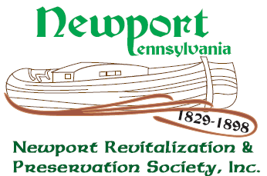
Return this form and check to NRPS, PO Box 13, Newport, PA 17074. Make your check payable to NRPS.

